
Mawsley Community Primary School

Child-on-Child Abuse Policy – our school promise:
We will help to keep children safe from child-on-child abuse
What does this mean?
- Sometimes children can hurt, upset or frighten other children.
- This can happen in school, outside school or online.
- It is never okay for one child to hurt or abuse another child.
- At our school, everyone has the right to feel safe, respected and listened to.

What might Child on Child Abuse look like?
Child-on-child abuse can include:
👊 Physical harm
Hitting, kicking, pushing, punching, biting or hurting someone on purpose.
🗣️ Hurtful words
Calling someone names, threatening them, making racist or discriminatory comments or deliberately trying to upset them.
😔 Bullying
Repeatedly being unkind, frightening, leaving someone out or making them feel unsafe.
📱 Online abuse
Sending nasty messages, sharing embarrassing pictures, threatening someone online or using technology to hurt another person.
❤️ Friendship and relationship abuse
Being controlling, threatening or unkind to someone because they are friends or have a relationship.
🚫 Sexual behaviour
Making sexual comments, jokes or gestures, touching someone in a way they do not want or pressuring someone to do something sexual.
📸 Sharing private pictures
Taking, asking for or sharing private or intimate pictures of another person.
😨 Making someone do something
Forcing, pressuring or threatening someone to do something they do not want to do.

🛑 Remember: IT IS NOT YOUR FAULT
If another child hurts you, scares you, threatens you or makes you do something you don't want to do:
IT IS NOT YOUR FAULT.
You will not be in trouble for telling an adult.
You do not have to deal with it on your own.

🗣️ TELL A TRUSTED ADULT
Use your network hand to choose a trusted adult or find a way to contact people who could help:
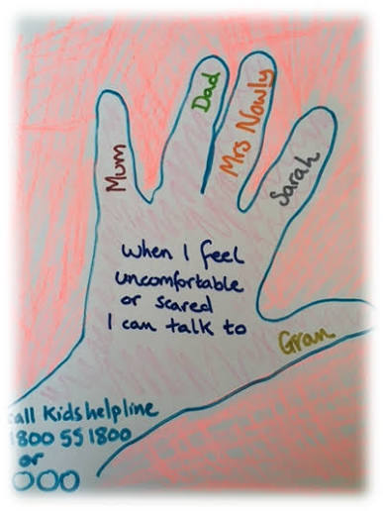

You can tell:
👩‍🏫 Your teacher
👨‍🏫 Another member of staff
💛 A trusted adult in school
🏠 Your parent or carer
🛡️ Our Designated Safeguarding Leads. These are:

Miss Harris Miss Cox Mrs Tedore
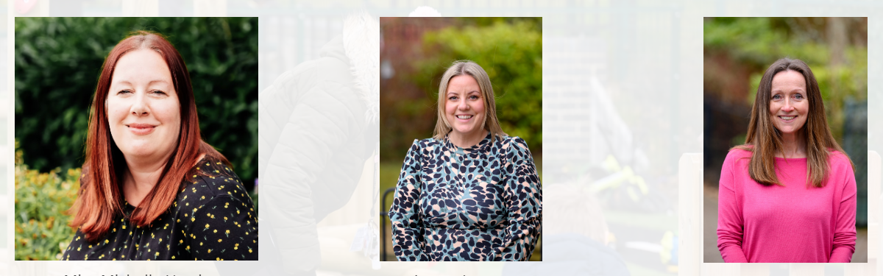
Mrs Groom Mr Weston Miss Pattle
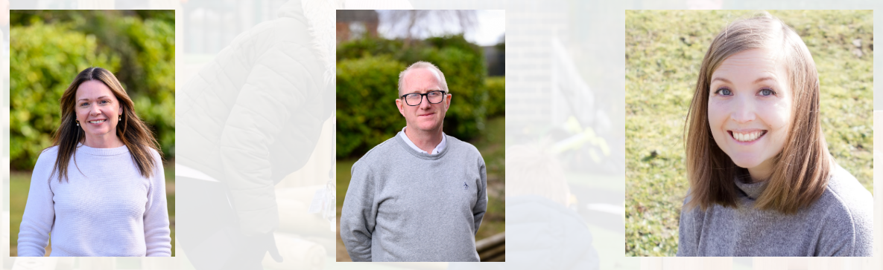
Mrs McCarlie

If the first person you tell does not understand, tell someone else.
Keep telling until someone helps.

